

**Asset prices, saving and the wider effects of monetary policy**

Speech given by

David Miles, External Member of the Monetary Policy Committee, Bank of England

At the pro.Manchester Business Conference 1 March 2012

I would like to thank Becky Maule and Arpad Morotz for research assistance, and others for helpful comments. The views expressed are my own and do not necessarily reflect those of the

Bank of England or other members of the Monetary Policy Committee.

Last month, the MPC voted to loosen monetary policy by expanding the size of its programme of asset purchases by £50bn to a total of £325bn. This comes after a period of three years during which Bank Rate has remained close to its lower limit of zero. This is unprecedented. The extraordinarily low level of Bank Rate and scale of the asset purchases – which at £325 billion will be the equivalent of about £12,500 for every household in the UK – is a reflection of the recessionary forces that were unleashed by the near collapse of the financial system in 2008 and whose effects are still being felt today.

Today I want to describe how I see the current stance of monetary policy, consider how asset purchases might be affecting the economy, and assess the view that such asset purchases are causing particular harm to those saving for retirement.

**Monetary policy**

At the February meeting of the MPC there were differing views on the right scale of the expansion of asset purchases. (I voted for a larger stock of assets than the majority). But the decision to make monetary policy more expansionary was unanimous. That decision reflected the aim of monetary policy – to meet an inflation target – and judgements about where inflationary pressures are likely to be over the next few years, the time over which changes in monetary policy today have their effect. CPI inflation has decreased sharply over the past few months: since its recent peak of 5.2% in September, inflation in January had dropped to 3.6% so had fallen back halfway towards the 2% target. And inflation is likely to continue to fall as domestically generated price pressures are restrained by downward pressure from unemployment and spare capacity, and the contribution of past energy and import price rises diminishes. In the light of our projections for inflation and growth, outlined in the February *Inflation Report*, the Committee all agreed that without further monetary stimulus it was more likely than not that inflation would undershoot the 2% target in the medium term. With the extra stimulus provided by continued asset purchases, the MPC’s latest projections imply that the risks around the inflation outlook, relative to the target, are broadly balanced by the end of the forecast period (Chart 1). The probability that inflation will be above 2% (the area in the chart above the horizontal line) is only marginally smaller than the chances that it is below 2% by 2015.

These inflation projections – which reflect an assessment of the balance between demand in the UK and the supply capacity of the economy – are absolutely central to monetary policy. Any such projection of how inflation might evolve must be based on some assumption of how monetary policy evolves. The projection shown in the so-called fan chart (Chart 1) is conditioned on a particular assumption about future policy – that Bank Rate follows a path in line with market yields and that the stock of assets purchased remains at the current level. This is an assumption made for the purposes of generating a forecast, a forecast that is conditional on a particular setting of monetary policy. The assumption on Bank Rate and the stock of asset purchases is, to use a bit of economics jargon, a conditioning path; it is NOT a forecast that the MPC makes of what its own future policy will be.

**Chart 1: February 2012 CPI inflation projection based on market interest rate expectations and £325 billion asset purchases**

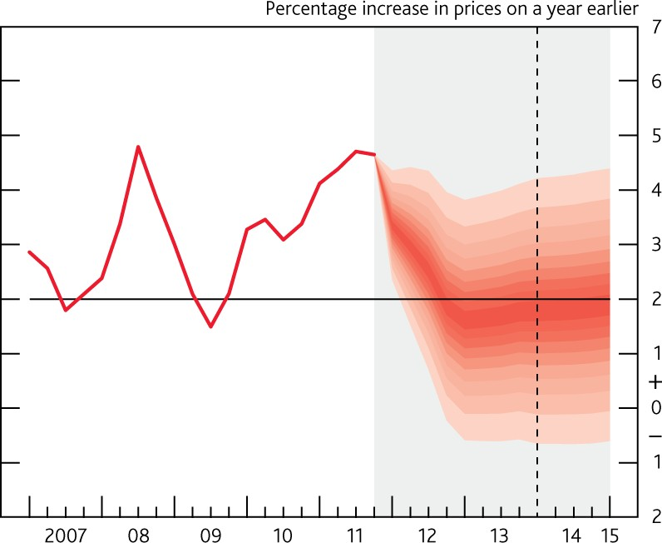

Source: Bank of England, *Inflation Report,* February 2012

The fan chart shown here is based on the assumption that Bank Rate follows a path that is consistent with the pattern of market interest rates of different maturities at the time of the *Report* (early February). That pattern of market rates implied that the first increase in Bank Rate might not come until the second half of 2014. It is the policy combination of a stock of asset purchases of £325 billion and a path for Bank Rate that is pretty much unchanged until the second half of 2014 that generates the probability assessments about future inflation that are shown in the fan chart.

Different assumptions about monetary policy could deliver an inflation projection with the risks around the inflation outlook, relative to the target, broadly balanced by the end of the forecast period. For example, it is possible that a path for policy that was looser in the near term (more asset purchases) but was then tightened at an earlier point (a rise in Bank Rate sooner than the second half of 2014) would result in a similar outturn for inflation as in the fan chart. And it might be the case that a path such as that could be a better one for the economy. Aggressively loosening monetary policy now might bring us closer to the point at which Bank Rate could be moved back towards a more normal level – and Bank Rate is certainly NOT at a normal level today. This is an argument that influences the way I see monetary policy today.

At the moment, with Bank Rate judged to have effectively reached its floor, monetary policy is being loosened through the purchase of assets, and those assets are government bonds (gilts). The objective of asset purchases is the same as for a cut in Bank Rate: to stimulate demand for goods and services and to prevent demand falling so much behind supply that inflation would fall below target and stay below it. I

sense that there is more agreement by people outside the Bank of England with the policy of making monetary policy very expansionary than with the means by which it is being pursued – which is through buying gilts. Two particular criticisms are made about the strategy of buying gilts: that it is ineffective as a means to boosting demand; and that it is having adverse side effects, particularly on people saving for retirement. Both those criticisms are worth considering carefully.

**The impact of asset purchases on demand**

There are 2 main channels through which I believe asset purchases boost demand (Figure 1). First, when assets (and today that means gilts) are purchased from the non-bank private sector, it is likely that the sellers of gilts will rebalance their portfolios, as the bank deposits they receive in return are unlikely to be very close substitutes for the assets sold. That portfolio rebalancing is likely to result in an increase in the demand for, and price of, other long-dated risky assets, like corporate bonds and equities. Those assets are likely to be closer substitutes for gilts sold than is cash (bank deposits); in terms of maturity and yield they are more

gilt-like. The rise in asset prices and decline in yields on these other assets may make it easier for many companies to raise funds, easing credit conditions. They will generate capital gains for households who are the ultimate owners of those risky assets, boosting their wealth. If households consume part of that increased wealth, or companies invest some of the extra funding raised on capital markets, demand (and GDP) will be higher. This is the portfolio rebalancing channel of asset purchases.

There is another way in which purchases work, particularly at times of stress in bank funding markets. The money received by non-banks for the assets purchased by the Bank of England is initially deposited at banks. Those extra funds might make banks more willing to expand lending. The extent to which they do so will depend on the form in which the money flows into banks – the more secure and long term the funding the more likely it will be to encourage banks to lend. Some of the funds that ultimately flow to banks as a result of asset purchases by the Bank of England might be in the form of term funding (e.g. as a result of banks issuing bonds), and that is more likely to facilitate bank lending than very short term money market flows.

Easing in bank lending conditions boosts demand, particularly for those entirely dependent on banks for credit, for example small companies.

It is difficult to quantify precisely the strength of these effects of asset purchases. My own view is that the portfolio balance channel – the first one – is the more consistent and reliable mechanism. The bank lending channel might be weak when banks are looking to de-lever, even though the flow of funds that asset purchases generate is particularly helpful when bank funding costs are high. A variety of studies carried out at several institutions have concluded that asset purchases increase demand and GDP.1 Economists at the Bank of England have used a variety of empirical methods to estimate the effect of the first tranche of

1 For example, see Chung, H, Laforte, J P, Reifschneider, D and Williams, J (2011), ‘Have we underestimated the likelihood and severity of zero lower bound events?’, *Federal Reserve Bank of San Francisco Working Paper no. 2011-01* and Lenza, M, Pill, H and Reichlin, L (2010), ‘Monetary policy in exceptional times’, *Economic Policy*, Vol. 25, pages 295–339.

£200bn of asset purchases in 2009-10. The results suggested that those asset purchases boosted GDP by about 1.5% to 2%.2

**Figure 1: Key channels for the impact of the Bank of England’s gilt purchases on domestic demand**

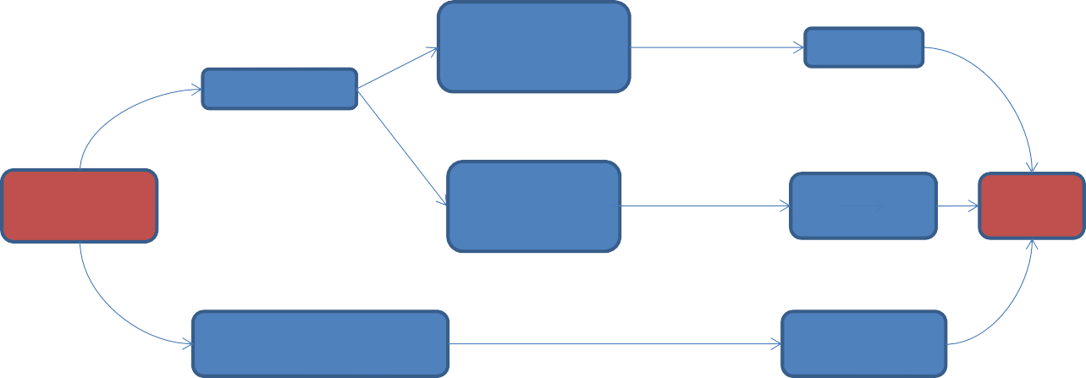

**Portfolio substitution**

**channel (always operates)**

Term premia  Yields on long‐dated risky assets 

Wealth 

Gilt yields 

Bank of

England gilt purchases

Cost of accessing

credit in financial markets

Credit risk

premia 

Domestic

demand

Bank deposits and liquid

assets

Availability of

bank credit

**Bank funding channel (may operate in conditions of stressed bank funding)**

**The effects of asset purchases on gilt yields**

As the figure above shows, ***one*** way in which the Bank’s asset purchases affect the real economy is through their effect on gilt yields. A decrease in gilt yields is only one part of the transmission mechanism, and it is certainly not the ultimate goal of the asset purchases. Movements in the yields on other, risky, assets are probably more important as the means by which asset purchases boost demand than are movements in gilt yields per se. Changes in the yields on any risky asset can, of course, be split up into a component equal to the change in gilt yields and a component equal to a change in the spread between the yields on the risky asset and gilts. So asset purchases by the central bank might have their main impact upon the prices (or yields) on risky assets via the impact on the spread over government bond yields rather than through shifting government bond yields. That is one reason why I think there is rather too much attention paid to the question of the impact of the Bank’s asset purchases on gilt yields.

Chart 2 shows what happened to the spread between yields on sterling corporate bonds and gilt yields over the past 5 years. During the course of 2009, when the Bank bought close to £200 billion of gilts, the spread between yields on corporate bonds and gilts fell by between 2000 basis points (for high yield bonds) and 200 basis points (for investment-grade, non-financial corporate bonds). Those shifts in spreads were far greater than the shift in gilt yields. Part of that large fall in spreads on corporate bonds reflects factors besides the Bank of England purchases of gilts. The Bank was also buying some corporate bonds. And

2 See Joyce, M, Tong, M and Woods, R (2011), ‘The United Kingdom’s quantitative easing policy: design, operation and impact’, *Bank of England Quarterly Bulletin*, Vol. 51, No. 3, pages 200–12.

other central banks were also buying assets. But the Bank’s gilt purchases were the dominant force reducing the stock of sterling fixed income assets held by the private sector.3 I believe that created more demand for sterling fixed income funding that was needed by companies. The issuance of sterling bonds by the non-bank private sector was unusually large in 2009. I believe that it was through its impact on corporate bond yields and issuance that much of the impact of the Bank’s asset purchases made then came through.

**Chart 2: Sterling corporate bond spreads for financials, non-financials and high yield(a)**

Basis points 3500

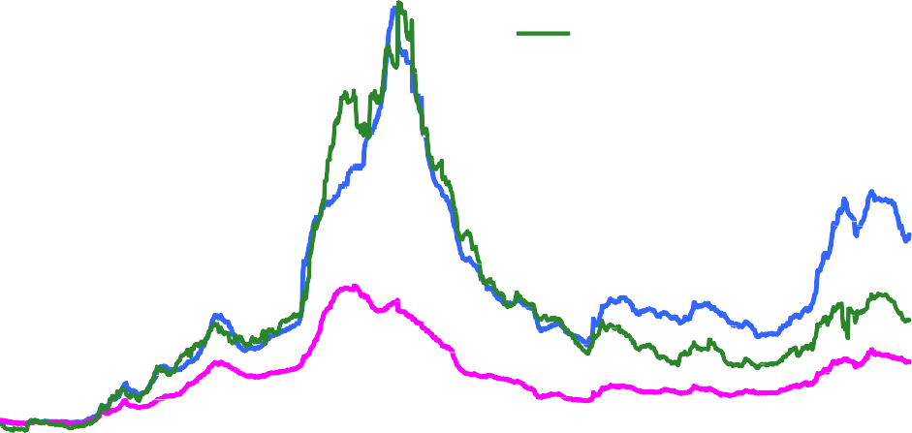

Financials (rhs) Non‐financials (rhs) High yield (lhs)

3000

Basis points

1200

1000

2500

2000

1500

1000

500

800

600

400

200

0 0

2007 2008 2009 2010 2011 2012

Sources: Bank of America/Merrill Lynch and Bloomberg.

1. Spreads of corporate bond yields over reference gilt yields.

Yields on the conventional gilts that the Bank has been buying have also fallen sharply since asset purchases began in early 2009 (Chart 3). I should note that this is not because the stock of gilts held outside the Bank of England has fallen sharply. In fact the stock of gilts held outside the Bank of England has increased since asset purchases began in March of 2009. Today the Bank is buying conventional gilts with maturities in excess of 3 years. In March of 2009 the market value of conventional gilts with maturity above 3 years held outside the UK public sector was around £380bn – about 27% of GDP. Today it is around

£485 billion, or 32% of GDP.

3 This was offset by new issuance to fund the fiscal deficit.

**Chart 3: Nominal yield curves of UK conventional gilts**

6

15‐Feb‐12

16‐Feb‐09

15‐Feb‐07

5

4

**Yield (per cent)**

3

2

1

0

0 5 10 15 20 25 30 35 40 45

**Maturity (years)**

Sources: Bloomberg, Bank of England calculations.

But relative to a counterfactual in which the Bank did not purchase any government bonds, demand for them has been higher and yields lower. Research carried out at the Bank suggests that the first round of asset purchases might have decreased gilt yields by around 100 basis points. That 100 bp figure needs to be seen in the light of the very much larger declines in corporate bond yields – the dramatic decline in spreads shown in Chart 2 means that corporate bond yields fell far faster than the fall in gilt yields. The fall in gilt yields since asset purchases began also needs to be seen in the light of the overall decline in gilt yields since before the financial crisis began. In early 2007, 10-year gilt yields were a bit under 5%; by early 2009 yields were around 3½%; today 10-year yields are a bit over 2%. Based on the Bank economists’ estimate of the impact of asset purchases, perhaps around half of the 250 basis points fall in 10-year gilt yields has been due to the MPC’s actions on gilt purchases. Some of the fall will have reflected an expectation that Bank Rate will be kept at a lower level for the next ten years than seemed likely in 2007.

But I think there are other factors at work besides UK monetary policy that have driven gilt yields down. It is worth noting that the yields on index-linked gilts have declined to exceptionally low (indeed unprecedented) levels. Chart 5 below shows that the (real) yields to maturity on inflation-proof debt issued by the UK government are now negative or close to zero for bonds with maturities that stretch out to 50 years. The Bank of England in its asset purchase operations has not bought any of these bonds.

**Chart 4: Stocks of all conventional and index-linked gilt holdings by sector, excluding central government(a)**

£ billions 1400

Other (households, local authorities, public corporates, PNFCs) Insurance corporations and pension funds

Other financial institutions Non-residents

UK monetary financial institutions, excluding Bank of England Bank of England

1200

1000

800

600

400

200

0

2005

2006 2007

2008

2009

2010 2011

Sources: ONS and Bank of England.

(a) Market values. All maturities. Total excludes central government holdings.

I think focusing on gilt yields risks both exaggerating and simultaneously understating the impact of the central bank’s asset purchases. It understates the impact because I think more of the effect of asset purchases works through changing the demand for *other* risky assets and that shows up in rather big shifts in their yield spreads over gilts; it exaggerates the impact of asset purchases because other factors have certainly been at work in driving the yield on UK government bonds lower.

And I believe that the criticism that gilt purchases are doing great harm for those saving for retirement also risks making a rather similar error. It seems to me likely that the very low level of real yields is related in large part to ‘safe haven’ asset flows. In the wake of the financial crisis, and with ongoing concerns about the indebtedness of some countries, it is likely that people’s perceptions about the probability of extreme, bad events, and possibly also their willingness to take risk, have changed. As the probability people attach to bad events goes up, it is likely that their demand for assets that are perceived to be ‘safe’ increases, and so the yields on those assets decrease.

It does not take particularly large changes in those probabilities to have sizable impacts on the real rate of return on ‘safe’ bonds. For example, research I carried out a few years ago suggested that if an extreme (bad) event was expected every 100 years, rather than every 133 years, the real rate of return on safe bonds

could fall from about 3.7% to 2.3% (Table 1).4 If an extreme and bad event thought likely to occur once every 200 years became seen as much more likely, so it happened once every 80 years, the real yields on safe government bonds might fall by about 400 bps. Such falls are larger than the decline in yields on most indexed gilts since the start of the financial crisis.

**Chart 5: UK spot real yield curves of index-linked gilts**

3

15‐Feb‐12

16‐Feb‐09

15‐Feb‐07

2

1

**Yield (per cent)**

0

‐1

‐2

‐3

0 5 10 15 20 25 30 35 40 45

**Maturity (years)**

Sources: Bloomberg, Bank of England calculations.

**Table 1: The impact of changes in the probability of extreme, bad events(a)**

Real rate of return on 'Safe' bonds Equity Risk premium Once every n

Probability (%) years

|  |  |  |  |  |
| --- | --- | --- | --- | --- |
| 0.10 | n=1000 | 7.29 | 8.94 | 1.65 |
| 0.40 | n=250 | 5.60 | 8.31 | 2.71 |
| 0.75 | n=133 | 3.67 | 7.59 | 3.91 |
| 1.00 | n=100 | 2.33 | 7.07 | 4.74 |
| 1.25 | n=80 | 1.00 | 6.56 | 5.56 |

Source: Morgan Stanley Research (2005).

1. The bad event in question here is one which if it happens reduces GDP by 38%.

4 See Miles, D, Pillonca, V and Baker, M (2005), ‘What should equities and bonds be worth in a risky world?’, *Morgan Stanley Research*. The bad event in question here is one which if it happens reduces GDP by 38%. Such an event might seem too extreme to be interesting. But UK GDP is now close to 15% below where one might have expected it to be had output grown at the long run average since the start of 2008. The shock to the GDP of some of the countries in Europe is larger again.

It may also be that people have become more risk averse over the recent past. And relatively small changes in investors’ risk aversion can also have significant effects: an increase in risk aversion will decrease the real rate of return on ‘safe’ bonds quite substantially.

So it is likely that the perception of UK government bonds as safe assets, alongside a shift in people’s desire to hold safe assets, has played a role in the fall in gilt yields in addition to the effects of the Bank’s asset purchases.

**The effects of asset purchases on those approaching retirement**

Clearly falls in gilt yields have an impact on the returns that investors receive. Part of the reduction in nominal gilt yields reflects asset purchases – though as I have noted much of it reflects other factors. People have raised legitimate concerns about the impact of the Bank’s asset purchases on those approaching retirement. That is understandable. Annuity rates have fallen by around 100 bps since asset purchases started in March 2009, and by around 150 bps from their recent peaks in 2008. A couple with a pension pot of £100,000 could have received an annual pension of around £6200 around three years ago, but would now get around £5200.5 Focusing just on the price of annuities it would seem that those close to retirement have seen the value of their pension saving fall by around 17%.

But it cannot be right to assess the impact of monetary policy upon the retirement resources of people by just focusing on what has happened to gilt yields and noting the impact on annuity rates. The impact of asset purchases (or more generally of monetary policy) must depend not just on what it does to gilt yields and annuity prices but also what it does to the value of the retirement savings of those about to buy annuities. If they hold government bonds then the capital gain on those bonds from lower gilt yields offsets the impact of the induced change in annuity rates. If they hold other assets – equities, residential property, land, corporate bonds – then the impact of monetary policy on those asset values needs to be factored in. An increase of about 19% in the value of a pension pot would provide the same yearly income as expected in March 2009 at current annuity rates. If monetary policy generates rises in other asset prices (besides gilts) it can offset some, or all – or more than all – of the effects of rising annuity prices. And the impact of monetary policy on the real economy – on GDP and on unemployment – will affect welfare too. Even someone about to leave the labour force will not be unaffected by changes in unemployment which affect the incomes of children, grandchildren, nephews and nieces.

It is worth considering this in more detail and in doing so to look at the portfolios of company pension schemes. Those portfolios will not be exactly the same as those of savers with personal pensions. And shifts in gilt yields will impact company schemes (and affect deficits and so company required contribution rates) rather than the pensions about to be received by newly retired employees. But the factor I want to

5 Based on a £100,000 annuity for a male aged 65 and a female aged 60, on a joint life, two thirds, guaranteed 5 years and level payments basis. Source: William Burrows.

focus on here is how monetary policy might have affected the balance between the value of the type of assets held by long-term savers and the cost of buying annuities; that will affect both company schemes and those owning personal pensions.

Chart 6 below shows aggregate portfolios of company schemes as measured in the Purple Book;6 this focuses on assets held in pension schemes with defined benefit liabilities.

**Chart 6: Composition of defined benefit company pension funds’ assets in 2011(a)**

Equities

4.4%

4.1%

1.6%

8.7%

41.1%

14.5%

17.8%

7.9%

Conventional government bonds (non index‐linked)

Corporate fixed interest securities

Index‐linked securities Insurance policies

Cash and deposits

Property

Other investments

Source: Pension Protection Fund / Pensions Regulator.

* 1. Data from the Purple Book (a joint publication of the Pension Protection Fund and the Pensions Regulator). It focuses on defined benefit schemes, predominantly in the private sector. In 2011 it covers assets of approximately £970bn, which is approximately 75% of pension funds’ total assets, based on 2010 ONS data.

Chart 7 shows how portfolio shares of these pension schemes have evolved since 2008. It appears that the proportion of assets that pension funds hold in nominal (conventional) government bonds has decreased over the past few years, while the share of corporate bonds has increased. That is consistent with the operation of the portfolio rebalancing channel of the Bank’s asset purchases outlined earlier, though it probably also reflects trends that pre-date those asset purchases.

6 Pension Protection Fund and The Pensions Regulator (2011), ‘The Purple Book: DB Pensions Universe Risk Profile.’ Available at [http://www.pensionprotectionfund.org.uk/Pages/ThePurpleBook.aspx.](http://www.pensionprotectionfund.org.uk/Pages/ThePurpleBook.aspx)

**Chart 7: Changes in the composition of defined benefit company pension funds’ assets**

100%

90%

80%

70%

60%

50%

40%

30%

20%

10%

0%

2008 2009 2010 2011

Equities

Other investments Property

Cash and deposits Insurance policies Index‐linked securities

Corporate fixed interest securities

Conventional government bonds (non index‐linked)

Source: Pension Protection Fund / Pensions Regulator, Bank of England calculations.

(a) Data from the Purple Book (a joint publication of the Pension Protection Fund and the Pensions Regulator). It focuses on defined benefit schemes, predominantly in the private sector. In 2011 it covers assets of approximately £970bn, which is approximately 75% of pension funds’ total assets, based on 2010 ONS data.

The Purple Book data suggest that a bit above 40% of the portfolio of assets of pension funds is in equities. Chart 8 below shows what has happened to the price of UK equities since the start of 2007. The low point in equity prices coincides with the start of asset purchases by the Bank of England. Since the couple of weeks preceding that date (5 March 2009) the UK stock market has risen by about 50%. Corporate fixed income securities make up over 15% of the assets of the pension funds covered in the Purple Book. Since the

run-up to the March 2009 announcement of asset purchases the yields on such bonds (to which prices are inversely related) have fallen sharply: by 240 bps on non-financial investment-grade bonds and by almost 2000 basis points on their high-yield counterparts.

Thus close to 60% of the assets held by company pension schemes have seen very large increases in value in the period since asset purchases began. That rise in values continued over the shorter period since asset purchases were resumed in October of last year. Since then the FTSE all share equity price index has risen by about 15%; yields on investment-grade sterling corporate bonds have fallen by about 25 bps and on

high-yield bonds by about 85 bps.

It is impossible to know what would have happened to equity prices and to the value of corporate bonds in the absence of the Bank’s asset purchases. If there was no plausible mechanism linking the two I would be sceptical about drawing any conclusion. But I believe there is a compelling economic argument linking very

large scale purchases of gilts by the central bank to a knock on impact boosting the demand for substitute assets like corporate bonds and equities.

**Chart 8: UK equity prices(a)**

7000

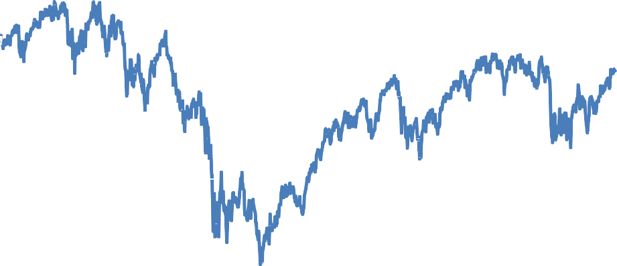

6500

6000

5500

5000

4500

4000

3500

3000

2007 2008 2009 2010 2011 2012

Source: Thomson Reuters Datastream.

(a) FTSE 100.

I think it is implausible to see the increase in equity and corporate bond prices in the UK over the past few months as unrelated to the policy actions of the Bank of England and other central banks. And those increases in asset values will have boosted the assets of pension funds, and of other savers, relative to a situation without asset purchases.

Nonetheless it is inevitable that there are some people that have been made worse off by the direct impact of the Bank’s asset purchases on gilt yields, and that have not benefitted much from the effects on the prices of other assets. Those people are amongst the losers from very low gilt yields. It will not be any comfort for people in this position to be told that any monetary policy action will have some distributional impacts. But if monetary policy actions could be vetoed so long as someone was made worse off then there could be no monetary policy.

The ultimate objective of the asset purchases is to boost nominal demand in order to prevent there being such slack in the economy that inflation stays below target. In the absence of the Bank’s asset purchases I am sure that investment and consumer spending would have been significantly weaker than they have been. Many more people would have been much worse off. Unemployment would have been even higher than it

currently is. Many of those who would have found themselves without a job are the children or grandchildren of someone nearing retirement.

**Conclusion**

Focusing on the impact of the Bank of England’s asset purchases on the yields of conventional gilts is understandable because those are the assets the Bank is buying. But it is a mistake to see the impact on gilt yields as a sufficient measure of the economic impact of policy. It is also a mistake to think that because asset purchases reduce gilt yields they must reduce the value of pension savings relative to the cost of securing a retirement income. The main impact of asset purchases should be seen as working through the effect on the prices of other assets (besides gilts) and on the cost and availability of funds to companies and households.